The Course To Financial Freedom
e-Journal

Thank you for signing up for The Course to Financial Freedom. My team and I are excited to be assisting you on your journey toward Financial Freedom.
To help get you started, we put together an e-journal, if you would like to take notes electronically. All you need is Microsoft Word or any other equivalent app that allows you to view .doc files. If you choose to, you can also print this document. To begin taking notes all you have to do is click on the highlighted area and a cursor will appear. You can start typing as you would like any other document.
Once you have completed the daily tasks, you can save this document to your hard drive and return to it at any time you like.
The course is designed to be completed over a 12-week period, with a new core lesson being released every Monday (Pacific Standard Time), along with daily challenges on Tuesday - Friday. This e-journal will assist you in taking valuable notes.
The course requires time and focus each day to make life-long progress. Stay focused through the 12 weeks and remember - you are doing the work to establish a healthy relationship with money. You’ve earned it after all.

Happy journaling!
Bob Wheeler
The Money Nerve

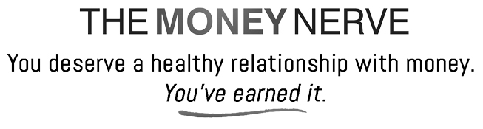
Begin typing notes here.

